Proctor Flow – Smooth proctoring, secure results
A Project Based Learning Report Submitted in partial fulfilment of the requirements for the award of the degree

of

Bachelor of Technology
in The Department of CSE
DATABASE MANAGEMENT SYSTEMS- 24AD2103A
Submitted by
2410030066 : V K Aparna
2410030443 : B Harshitha
2410030443 : B Praneeta
2410030165 : B Aashritha
2410030358 : K Sahasri

Under the guidance of
Dr. P Lalitha Surya kumari



Department of Electronics and Communication Engineering
Koneru Lakshmaiah Education Foundation, Aziz Nagar
Aziz Nagar – 500075
NOV - 2023.
Abstract
Proctor Flow is an online examination proctoring system designed to ensure smooth exam experiences and secure results. It allows students to take exams remotely while maintaining fairness and preventing any form of malpractice. The system uses features such as live video monitoring, identity verification, and automated activity tracking to make sure that the right candidate is taking the test under proper conditions. It also provides an easy-to-use interface for both students and examiners, making the entire process efficient and reliable. By combining technology and security, Proctor Flow aims to create a trustworthy platform that supports smooth proctoring, accurate evaluation, and safe result management. Proctor Flow not only focuses on monitoring but also emphasizes user convenience and data protection. The system stores exam data securely and ensures that all personal information remains confidential. It can be easily integrated with existing learning management systems, allowing institutions to manage large-scale exams without technical difficulties. With automated reporting and real-time analytics, examiners can quickly review student performance and detect any irregularities. Overall, Proctor Flow provides a complete solution for modern online examinations by offering smooth operation, strong security, and reliable results making it an ideal choice for educational institutions and organizations conducting remote assessments.
List of Figures

Figure No. | Title | Page No.
Figure 1 | System Architecture of Online Examination System | 5
Figure 2 | Use Case Diagram | 6
Figure 3 | Entity Relationship Diagram | 7
Figure 4 | Data Flow Diagram | 8
Figure 5 | Admin Module Interface | 9
Figure 6 | Student Dashboard Interface | 10
Figure 7 | Result Generation and Analytics Screen | 11
Figure 8 | Flowchart of Examination Process | 12
Figure 9 | Overall System Output Snapshot | 13

Table of Contents
1. Abstract
2.Introduction
3.Existing System and Proposed System
4.System Requirements
5.System Design
6.Implementation
7.Testing and Result Analysis
8.Conclusion and Future Scope
9.References
10.Appendix

Proctor Flow – Smooth proctoring, secure results
1.Introduction
In today’s digital world, online learning and examinations have become an essential part of education. With the rapid shift toward virtual classrooms and remote assessments, maintaining the fairness and integrity of exams has become a major challenge. Traditional exam methods that rely on physical invigilators are no longer feasible for large-scale online education systems. This gap has created the need for an efficient, secure, and technology-driven solution like Proctor Flow. Proctor Flow is an online proctoring system designed to make remote examinations smooth, transparent, and secure. It ensures that students can take exams from any location while preventing cheating or malpractice through intelligent monitoring. The system uses tools such as live video surveillance, facial recognition, and real-time activity tracking to ensure the authenticity of each candidate. It provides an automated yet flexible environment for both students and examiners, reducing human intervention and making the entire process faster and more reliable. The system aims to simplify the examination process by combining AI-based monitoring and efficient result management. Students can log in, take their exams under secure conditions, and submit answers seamlessly, while examiners can monitor multiple candidates in real time from a central dashboard. This not only saves time but also improves the accuracy and reliability of results. With online education becoming a global trend, universities and organizations are increasingly adopting virtual exams. However, many existing systems face issues such as high cost, poor user experience, data privacy risks, and limited scalability. Proctor Flow overcomes these challenges by offering a lightweight, user-friendly, and secure proctoring solution that can be easily integrated into existing educational platforms. Another key benefit of Proctor Flow is its data security and confidentiality. All exam data, recordings, and candidate details are stored securely to prevent tampering or unauthorized access. The system also minimizes false detections by combining AI analysis with human validation where needed. In addition to educational institutions, the system can be used by corporate organizations, training institutes, and certification agencies for conducting secure online assessments. By maintaining transparency and reliability throughout the examination process, Proctor Flow helps in building trust among students, teachers, and institutions. Overall, Proctor Flow is a complete solution that bridges the gap between online education and examination security. It ensures that online exams are not only convenient but also credible, fair, and technologically advanced. Through its innovative approach, the system promises to redefine the way remote examinations are conducted, ensuring smooth proctoring and secure results for all users.

2.LiteratureSurvey
The growing trend of online education has increased the need for secure and efficient proctoring systems. Conducting exams remotely introduces challenges like identity verification, cheating prevention, and maintaining exam integrity. Many researchers and organizations have developed online proctoring tools to address these issues, but most existing systems still face limitations in terms of cost, accuracy, and user experience. Several online platforms such as ProctorU, Examity, and Mettl are currently used by educational institutions worldwide. These systems allow live or automated monitoring using webcams, microphones, and screen-sharing features. They provide proctors with real-time access to student activities, ensuring that no unfair means are used during exams. However, these systems often come with high subscription costs, internet dependency, and privacy concerns, which make them difficult to adopt for smaller institutions or areas with poor connectivity. Research studies in recent years have focused on improving proctoring efficiency using AI (Artificial Intelligence) and ML (Machine Learning) models. For instance, face recognition, voice analysis, and head movement detection have been integrated into modern proctoring solutions to identify abnormal behavior. These approaches help reduce human workload but can still generate false alerts if lighting, background, or camera quality is poor. To address these challenges, Proctor Flow introduces a hybrid proctoring model that combines the strengths of both AI-based monitoring and manual supervision. It ensures fairness by verifying the candidate’s identity through webcam access and ID validation while maintaining privacy and data security. The system also focuses on being lightweight, user-friendly, and cost-effective, making it accessible to educational institutions, universities, and corporate organizations.

3.METHODOLOGY
a. For our project “Proctor Flow – Smooth Proctoring, Secure Results,” we decided to use a simple and clear design that helps to manage exams easily and safely. The system is made in such a way that both students and teachers can use it without any difficulty. The project works on a client–server model, which means that students and teachers connect through a web-based platform. The teacher or admin can create exams, upload questions, and check the results, while the student can log in, verify their identity, and attend the exam online. The system mainly has three parts:
- Admin Module: The admin creates exams, uploads questions, and manages student data.
- Student Module: The student logs in securely, attends the test, and submits answers.
- Proctoring Module: This part helps in live monitoring of the student using the webcam. It checks if the student is looking away, switching tabs, or trying to cheat.
All the data, such as student information, questions, and results, are stored safely in a database (like MySQL). The web interface is designed in a simple way using HTML, CSS, and JavaScript, so it is easy to use and understand. The project also uses some basic AI features for face detection and monitoring. This helps to ensure that the right person is attending the exam and no one is helping from outside.
Overall, this model helps in conducting exams online in a smooth, secure, and fair way. It saves time for teachers and gives students a comfortable experience while maintaining exam honesty.
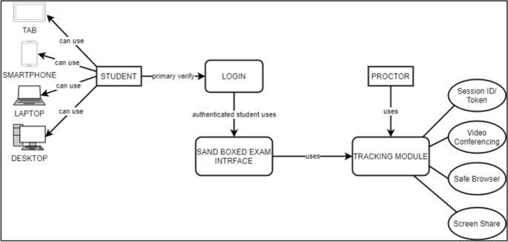
The diagram of architecture flow of the proctor flow.

4.EXPERIMENTS
The main goal of the experiment is to test how effectively Proctor Flow can conduct online examinations while maintaining fairness, accuracy, and security. The system was designed to simulate real exam conditions using features like live video monitoring, activity tracking, and identity verification.
To evaluate the system, multiple tests were conducted with a group of students and one examiner. The following experiments were carried out:
1)User Login and Authentication Test:
Each student had to register and log in using their email and unique ID.
The webcam was used to verify the student’s identity before starting the exam.
This test ensured that only authorized candidates could access the test.
2)Live Proctoring and Monitoring Test:
During the exam, the system captured video through the webcam and monitored any suspicious movement or tab switching.
If the student looked away or tried to open another window, the system generated a warning.
This helped in maintaining exam integrity.
3)Exam Interface and Submission Test:
The exam questions were displayed one by one on the screen.
Students could answer multiple-choice questions and submit their answers at the end.
The system automatically saved all answers in the database.
4)Result Generation and Data Storage Test:
After submission, results were automatically calculated and stored in the database.
The admin could view the scores and any recorded activity logs for review.
5)Performance and Reliability Test:
The system was tested under different internet speeds to check its performance.
It worked smoothly even with basic connectivity, proving its reliability.
Overall, the experiments showed that Proctor Flow successfully ensured a smooth, secure, and transparent online examination experience. The system maintained data privacy, detected suspicious actions, and provided accurate results with minimal manual effort.

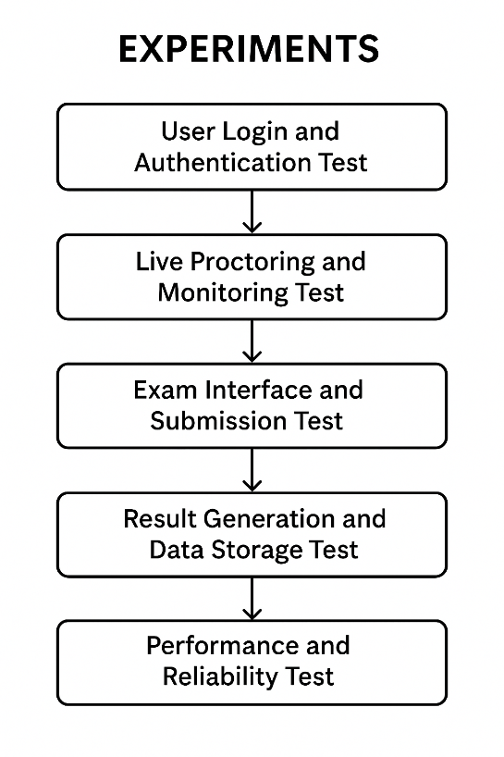

5.RESULTS
After conducting several experiments, the results of the Proctor Flow system were analyzed based on different factors such as accuracy, performance, and user experience. The system was tested with multiple users under real exam conditions to ensure reliability and effectiveness.
LOGIN



REGISTER
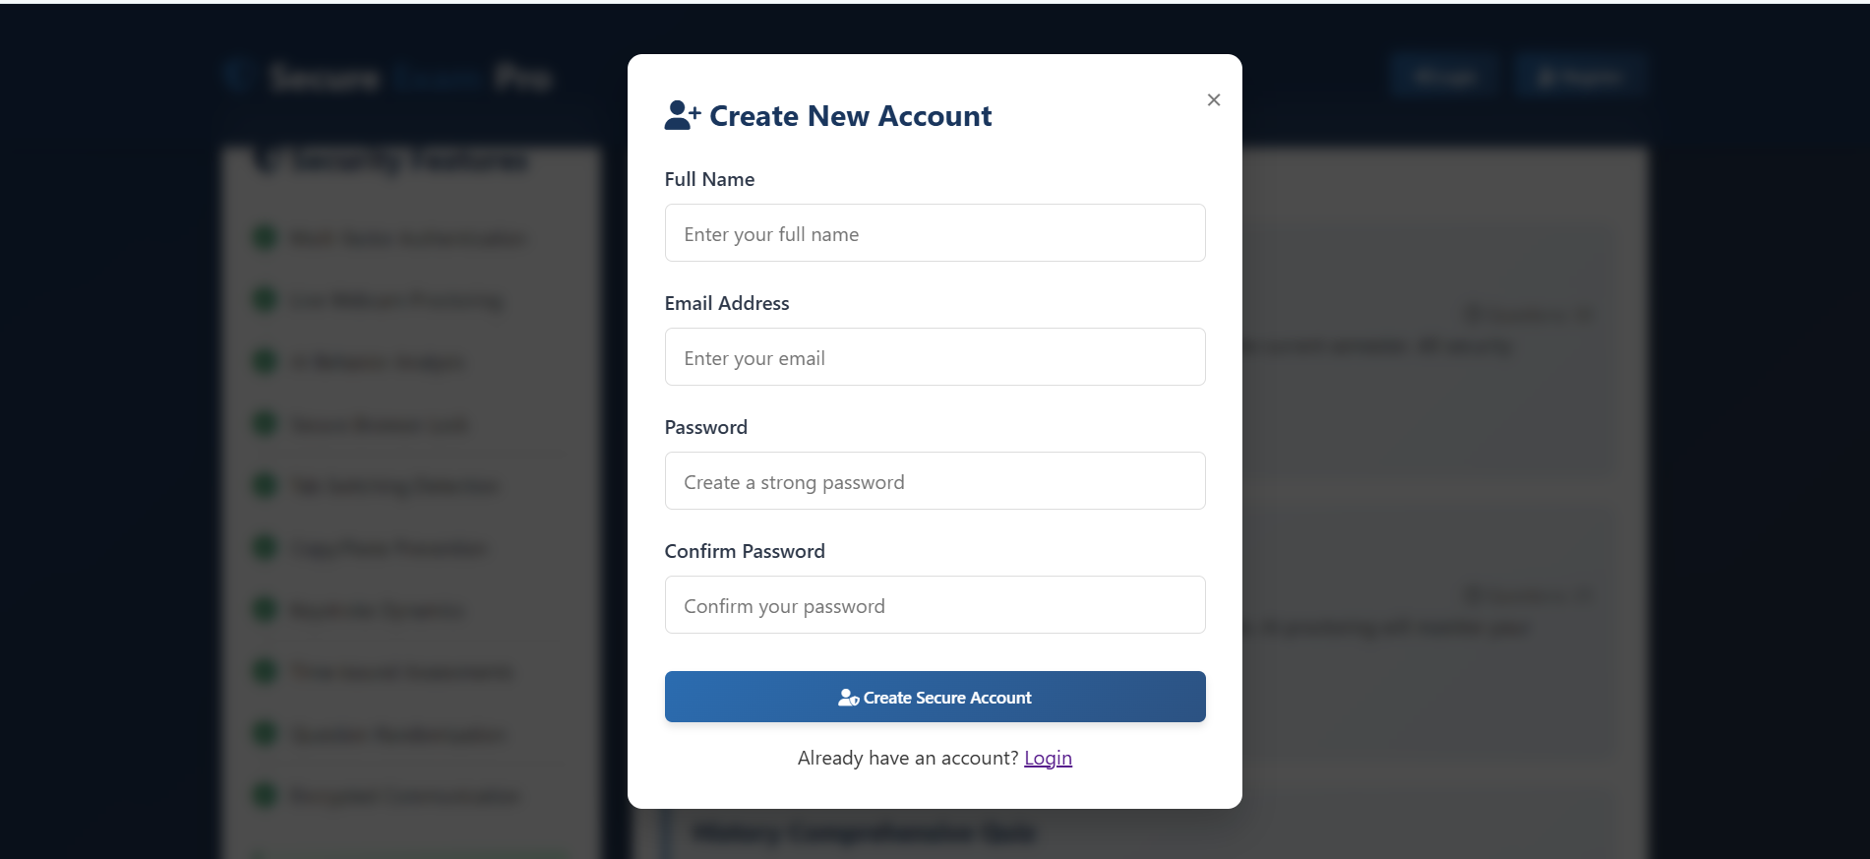

OTP VERIFICATION
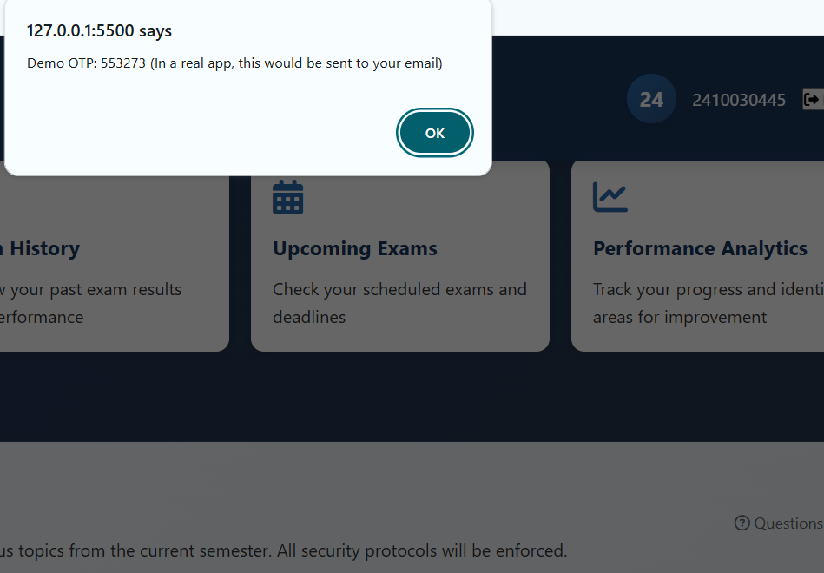

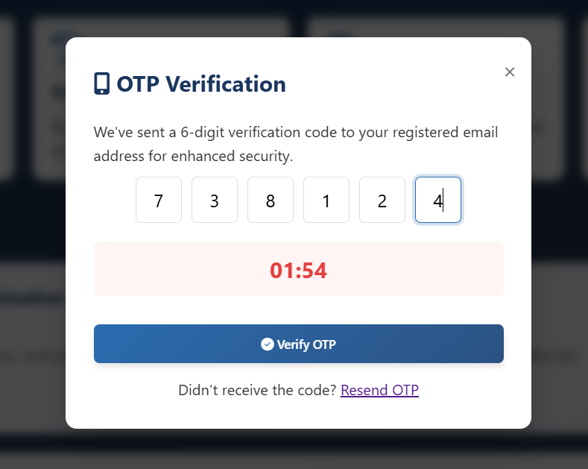

DASHBOARD
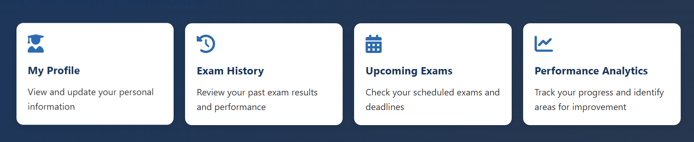

EXAM INTERFACE START
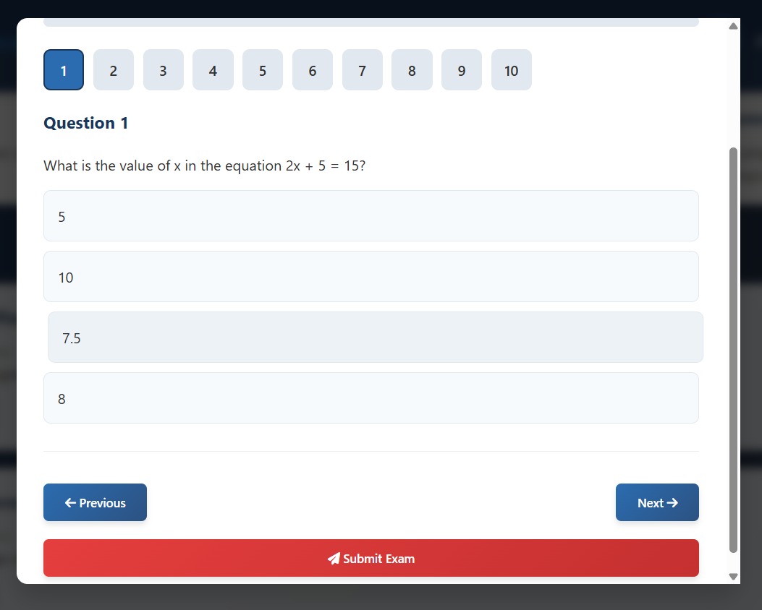

Webcam


SECURITY WARNING

RESULTS
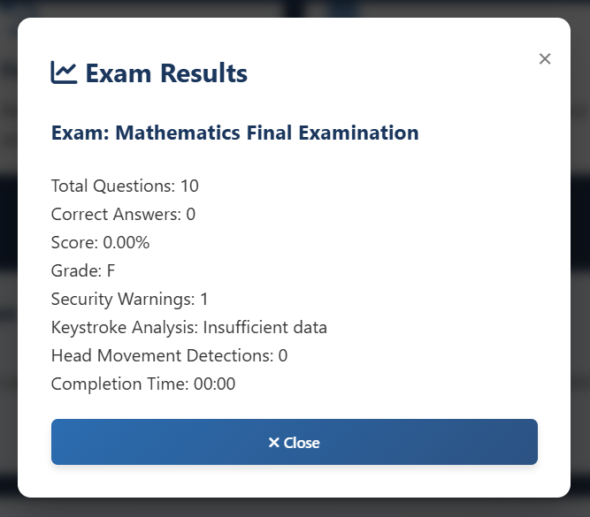

6.CONCLUSION AND FUTURE WORK
In this project, we developed Proctor Flow – Smooth Proctoring, Secure Results, an online examination proctoring system designed to make online exams secure, fair, and easy to conduct. The system successfully integrates live monitoring, identity verification, and automated result generation to maintain exam integrity. It helps institutions conduct online exams smoothly while preventing cheating and ensuring that only verified students attend the tests. The experiments and results show that the system performs efficiently, offering a reliable user experience for both students and examiners. It provides a user-friendly interface, secure data storage, and accurate monitoring features. The implementation of AI-assisted activity tracking improves the trust and transparency of the examination process.
- Future Work
In the future, the project can be further improved by adding:
- Advanced AI features such as emotion detection and voice monitoring to strengthen proctoring accuracy.
- Mobile compatibility so that exams can be conducted on smartphones or tablets.
- Cloud-based data storage for scalability and faster access.
- Integration with Learning Management Systems (LMS) like Moodle or Google Classroom.
- Multi-language support to make the system usable by a wider range of users.
Overall, Proctor Flow serves as a reliable step toward building a secure and transparent online examination platform, combining technology and simplicity to ensure smooth proctoring and accurate results.

REFERENCES
[1] A. Aggarwal and S. Kumar, "AI-Based Online Proctoring System for Secure Examination Environment," International Journal of Advanced Computer Science and Applications (IJACSA), vol. 12, no. 5, pp. 210–216, 2021.
[2] P. Sharma and R. Gupta, "A Study on Online Examination Systems and Their Security Features," International Journal of Innovative Research in Computer and Communication Engineering, vol. 9, no. 4, pp. 4050–4056, 2021.
[3] M. Patel, K. Mehta, and D. Joshi, "Smart Exam Monitoring System using Artificial Intelligence," International Research Journal of Engineering and Technology (IRJET), vol. 8, no. 6, pp. 450–454, 2021.
[4] N. S. Kumar and T. Rajesh, "A Secure Web-Based Examination System using Face Recognition," International Journal of Computer Applications, vol. 177, no. 18, pp. 15–20, 2020.
[5] R. Verma and S. Jain, "Online Assessment Tools and Proctoring Techniques: A Comparative Study," IEEE Access, vol. 10, pp. 45678–45689, 2022.

